Managing Quality

Directions
Complete the simulation found on the Assignment Manager page on the Pearson site and complete the questions below.

Questions
- What were the first initial investments and why?
  - I first invested in training and hiring staff, because a major complaint people had about the restaurant was the staff were untrained and unable to take propper orders.
- What were the following results?
  - Total profits
    - $378,758
  - Star rating
    - 4.5
  - Average failure rate
    - 13.18%
  - Cost of quality
    - $343,077
- How was it decided whether to invest in the cheaper or the more expensive option?
  - I decided to invest in a cheaper or more expensive option based on how large the problem was, if it was temporary or long term, and the number of customers who complained about different things, where I would invest in the more expensive options. There were also times where a cheaper option was preferred such as when I could have staff check items before receiving them rather than change suppliers.
- What is the difference between the cost of an internal and external failure expense?
  - An internal failure is a cost of quality that happens before a product reaches a customer. Once the product has reached the customer, if the item is defective and needs to be returned or the quality to the customer is low, then it is an external failure expense.
- Were the goals reached for the simulation? If not, how could it have been improved? If yes, then what was done that led to the success?
  - I did reach the goals for the simulation, but I did it by primarily spending more than others might have. I tended to invest more in the longer term problems, which was good for ratings in the long run, but had significant upfront investments. I could have likely spent less money, but it would have impacted the quality greatly.

Overview
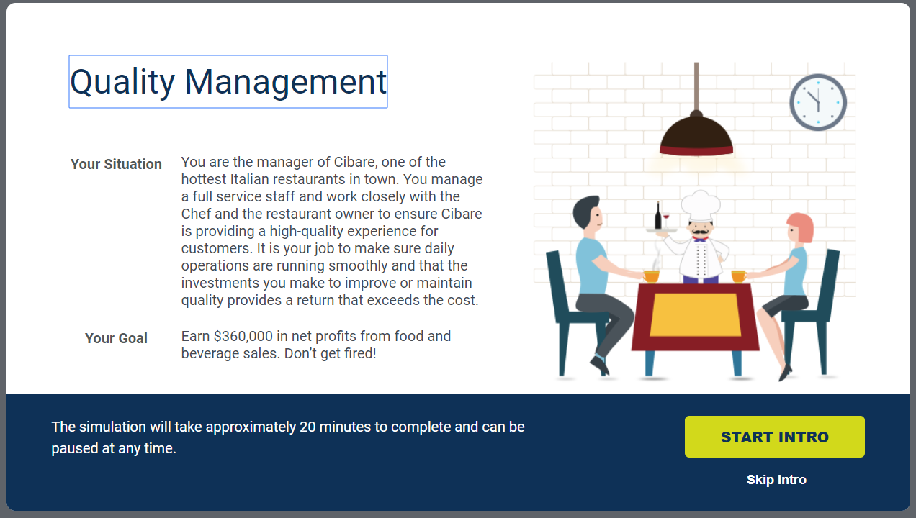

Dashboard – Final
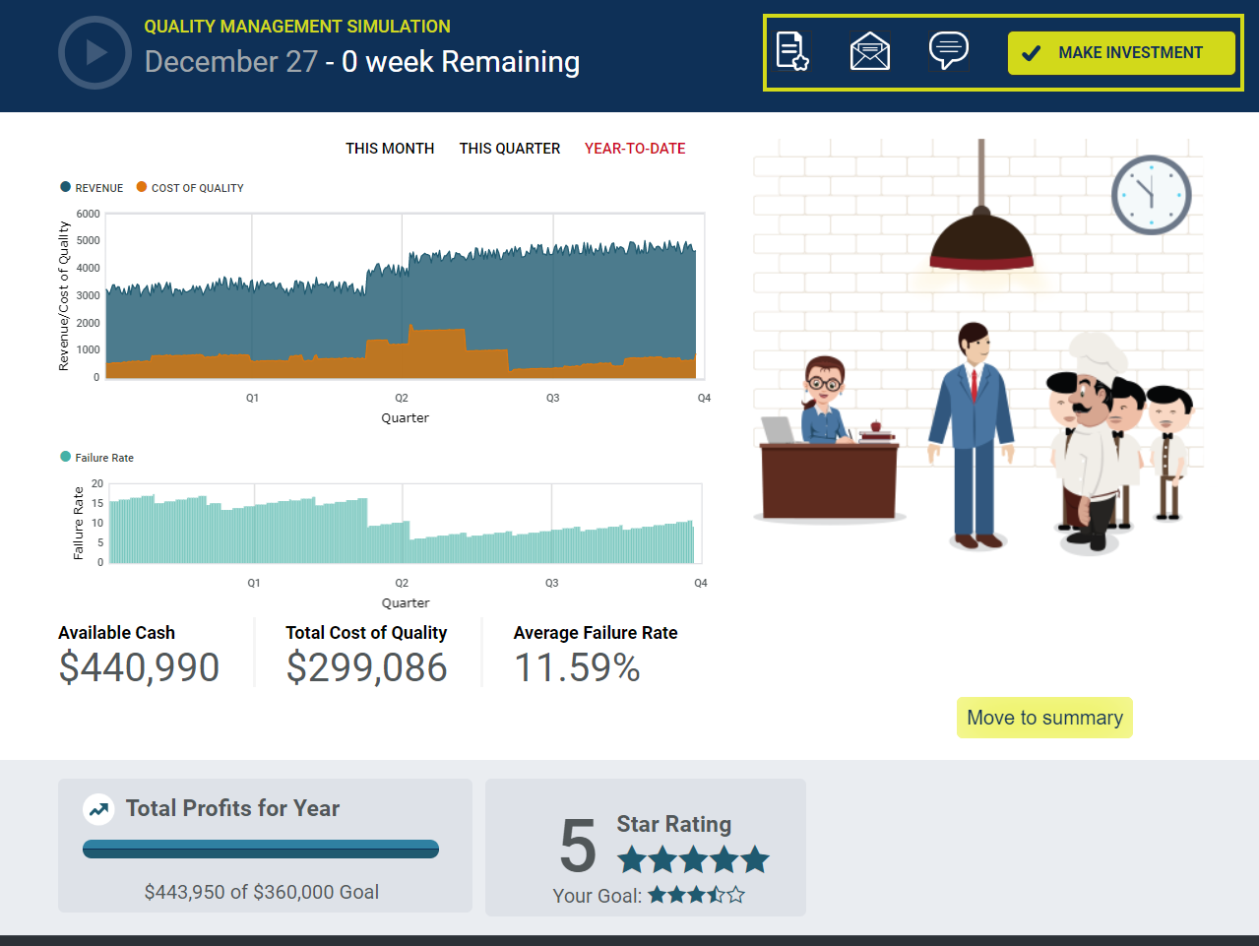

Summary – General Feedback
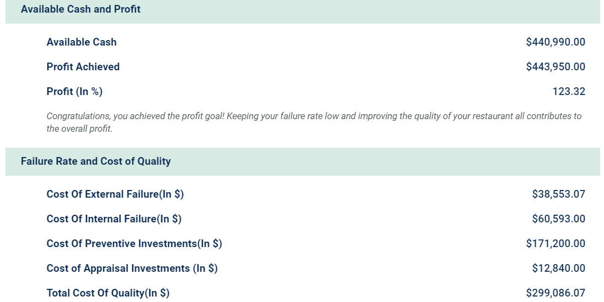
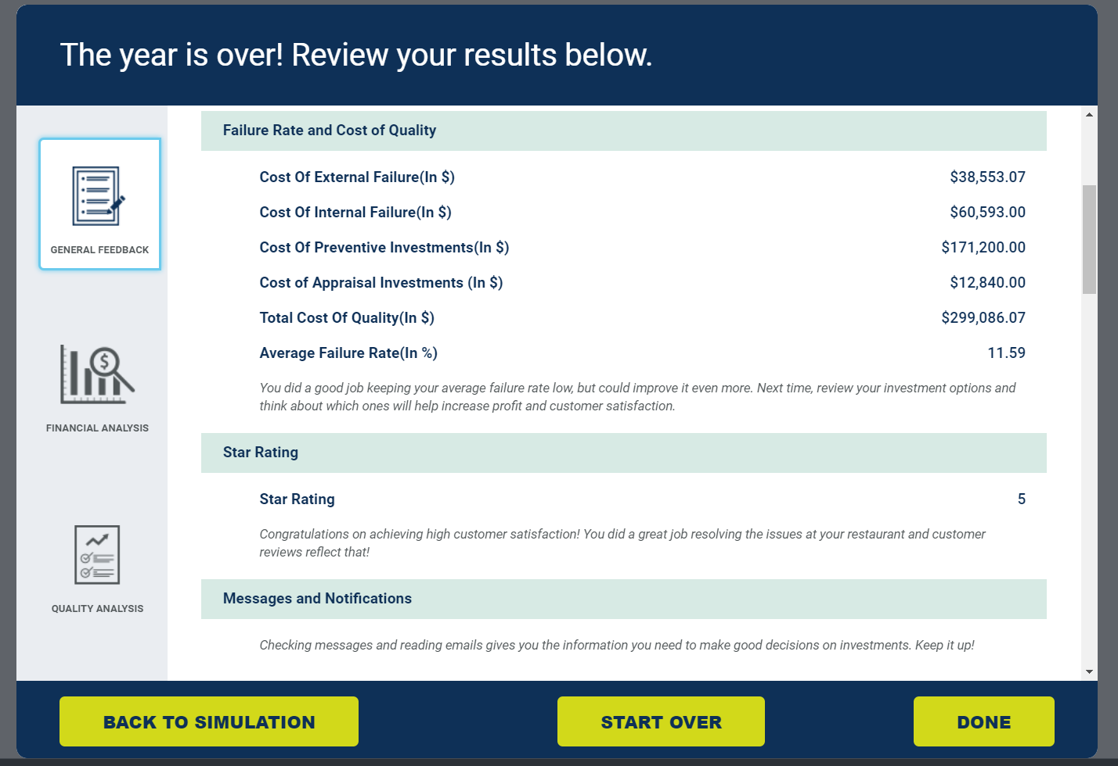

Summary – Financial Analysis
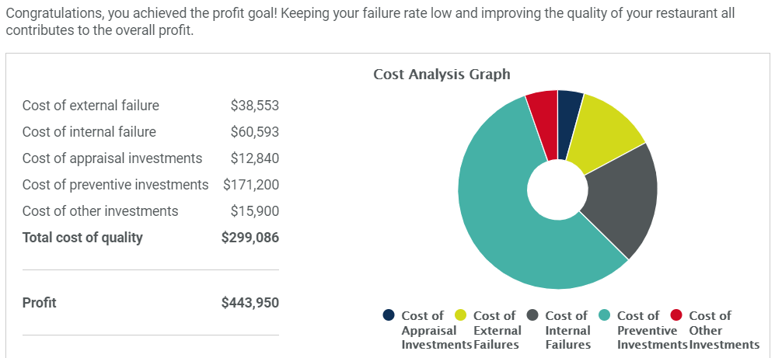
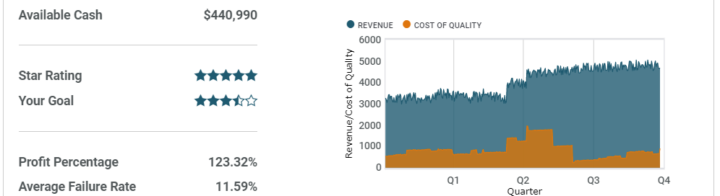

Summary – Quality Analysis
